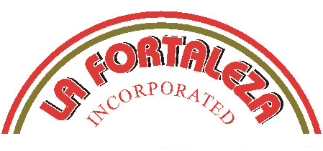
SPECIFICATION WORKSHEET

Product: SOPES

Code: 04560(SOPE-06)

Vendor: La Fortaleza, Inc.

Sales Rep: Ramiro Ortiz Phone #: (323) 261-1211

Technical Rep: David Ortiz Phone #: (323) 261-1211

Manufacturing Location: Los Angeles

Address: 525 N. Ford Blvd.
Los Angeles, CA 90022

Product Description: Handmade Sopes

Ingredient statement: White corn, Water, Salt, Baking Powder, Calcium Propionate, and a trace of Lime.

Purpose: To be fried and filled with refried beans, meat, lettuce, chesse and toped with sour cream.

Code Date- Where on package and method to decipher:
The “BEST BY” date is on the individual package and on the box panels.

Shelf Life and Storage:
Shelf life on the Handmade Sope is 30 days refrigerated @ 40⁰F .
CHEMICAL STANDARD LIMIT\RANGE AOAC TEST
pH: 7.5 6.5-8.0 943.02
Moisture: 55% 50-60% 925.10

MICROBIOLOGICAL
Standard Plate Count: 10,000
Yeast: <10
Mold: <10
Coliforms: <10
E. Coli: <10
Salmonella: NEGATIVE
Staph: <10

PHYSICAL STANDARD RANGE
Weights per piece: 1 oz 0.92-1.08 oz
Weight per bag: 25 oz 11-13 oz
Weight per case: 18 lbs. 16.5-19.5 lbs
Dimensions: 6” 5.5-6.5
Color: White with Toast Marks

PACKAGING
Case Dimensions: 13.75 x 13.75 x 5.375
Case Cube: 0.588
Case Burst Strength: 250 lbs.
Counts: 6 pks/cs.

NUTRITIONAL INFORMATION
This information will be used to answer guest inquiries and build your nutritional database
Serving Size: 1 Sope (59g)
Serving Per Container 12

Amount per Serving
%Daily Value *
Calories: 110
Calories from Fat: 10
Total Fat: 1.5g 2%
Saturated Fat: 0.5g 1%
Trans Fat: 0g

Cholesterol: 0mg 0%
Sodium: 280mg 12%
Total Carbohydrates: 23g 8%
Dietary Fiber: 2g 6%
Sugars: 0g
Protein: 2g

Vitamin A: 0%
Vitamin C: 0%
Calcium: 15%
Iron: 4%

Percent Daily Values are based on a 2,000 calorie diet.

Source of Nutritional Information: U.S. Aglabs

Person completing this information: Ramiro Ortiz, Jr.

Signature:

Name (print): Ramiro Ortiz, Jr.



